EBU6304 Software Engineering Group Project

2025-26
Group number | 83
member 1 | QM no: 231224398 | Name: Youshen Xv
member 2 | QM no: 231224723 | Name: Jiayi He
member 3 | QM no: 231224114 | Name: Yvfu Su
member 4 | QM no: 231224273 | Name: Bingyuan Huang
member 5 | QM no: 231225074 | Name: Yunpeng Fu
member 6 | QM no: 231224985 | Name: Youkun Chen

First report

Requirements
1.1、Fact-Finding Techniques
We adopted a combination of background reading, interview, and brainstorming to identify requirements for the BUPT International School TA Recruitment System.
1.1.1 Background Reading: We thoroughly analyzed the project handout, existing recruitment processes (form-based and Excel-based workflows), and typical TA recruitment scenarios in international schools to extract baseline functional and non-functional requirements.
1.1.2 Interview: We conducted semi-structured interviews with Module Organisers (MO), school administrators, and potential TA applicants to collect real-world pain points, such as scattered application materials, unclear status tracking, and inefficient workload statistics.
1.1.3 Brainstorming: Based on the handout’s suggested features and interview feedback, the team brainstormed additional practical functions to enrich the system while keeping the scope feasible.

1.2、Project Overview
This project develops a TA (Teaching Assistant) Recruitment System with 10 core user stories across 5 sprints. Functions are delivered by priority to launch core features first.
1.2.1 Sprint 01: Basic System Setup
Build foundational functions: role‑based registration and login for applicants, recruiters, and admins; recruiter position posting.
Deliver secure identity verification, password encryption, and full position management.
1.2.2 Sprint 02: Application & Review
Implement applicant functions: position browsing, application submission, and resume upload.
Build recruiter functions: application review, resume viewing, and quantitative scoring.
Complete the application‑to‑review workflow.
1.2.3 Sprint 03: Interview Management
Develop interview notice sending and applicant confirmation.
Support interview result entry, final admission list publishing, and automatic result notifications.
Close the full recruitment process.
1.2.4 Sprint 04: Query & Data Visualization
Enable applicants and recruiters to query application, review, and interview records.
Provide admins with system‑wide statistics and visual charts.
Support filtering, sorting, and data export.
1.2.5 Sprint 05: System Admin & Optimization
Implement admin permission control, account management, and operation logging.
Optimize system performance, database queries, and frontend speed.
Add global exception handling and stable logging mechanisms.
1.2.6 Project Management Rules:
Sprint reviews to validate functions
Weekly risk assessment
Full testing and 100% bug fixing
Daily standups for team alignment

1.3、Prioritisation Methods
We adopted the MoSCoW Method as the core function prioritisation method of the project, and combined with the user role demand urgency to classify and rank all the functions of the TA Recruitment System. We divide the functions into four priority levels: Must-have, Should-have, Could-have, and Won’t-have (this iteration), which ensures that the core value of the system is realised in the early iteration stage, and the functional development is closely combined with the actual needs of users. The specific prioritisation results are as follows:
1.3.1 Critical (Must-have): This part includes the core functions that determine the basic operation of the system, which are the rigid needs of TA and MO users, and are developed in Iteration 1 and Iteration 2.
1.3.2 High (Should-have): This part includes the important functions that improve the usability of the system and meet the basic work needs of MOs, which are developed in Iteration 3.
1.3.3 Medium (Could-have): This part includes the optional functions that optimise the user experience, which are developed in Iteration 4 according to the actual development progress and test results.
1.3.4 Low (Won’t-have): This part includes the extended functions with low demand urgency and high development complexity, such as AI-powered skill matching and workload balancing. These functions are recorded in the Product Backlog as the follow-up expansion direction of the system, and will not be developed in this project iteration to ensure the focus on the realisation of core functions.

The all functions and their priorities refer to the appendix which is an excel file named “ProductBacklog_group83”

1.4、Estimation Methods
For the development effort and time estimation of the TA Recruitment System, we adopted the Planning Poker Method (Agile classic estimation method) combined with the Task Breakdown Structure (TBS) to carry out the estimation work, and the estimation unit is person-day (the working time of one team member in one day), which ensures the objectivity and accuracy of the estimation results, and provides a reliable basis for the formulation of the iteration plan and the division of team member tasks.
1.4.1 Task Breakdown Structure (TBS): First, we decompose the whole project into several large functional modules according to the system function modules, such as user authentication module, TA personal profile module, job browsing module, job application module, MO job release module, data storage module, etc. Then, each large module is further decomposed into fine-grained sub-tasks, such as the user authentication module is decomposed into "login page design", "role selection function development", "registration information verification", "password encryption storage" and other sub-tasks, so as to avoid the deviation of estimation caused by overly rough task division.
1.4.2 Planning Poker Method: All 6 team members participate in the estimation process together. Each member holds a set of planning poker cards with different numerical values (representing person-days), and independently estimates the required person-days for each fine-grained sub-task without mutual interference. After the independent estimation, the team members announce their estimation results at the same time: if the results are highly consistent, the value is determined as the estimation result of the sub-task; if there are large differences, the members with high and low estimation values explain their reasons respectively, and conduct a second round of estimation after full discussion until a unified estimation result is reached.
1.4.3 Estimation Result Integration: After completing the estimation of all sub-tasks, we integrate the estimation results of each module, and combine the team's actual working time (lab time + independent development time) to allocate the development tasks of each module to the team members reasonably. At the same time, we reserve 10%-15% of the buffer time in the total estimation time to deal with unexpected problems in the development process (such as bug repair, demand adjustment, technical difficulties), ensuring that the iteration plan can be completed on schedule.

1.5、Requirements Mind Map
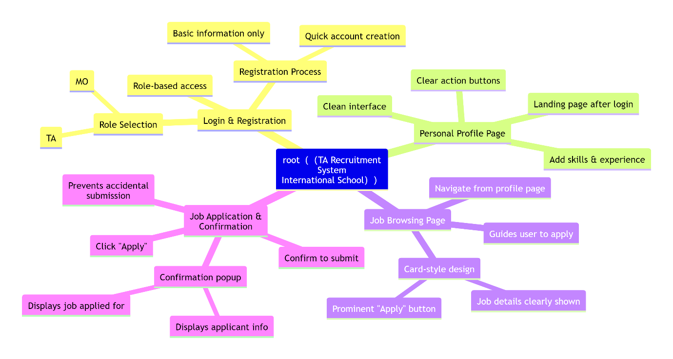

Supporting material
2.1、 Interview Questions
2.1.1 For Module Organisers (MO)
- What is the current process for you to release TA recruitment positions and collect applications?
- What problems do you often encounter in the manual screening of TA applicants and resume review?
- What core information (e.g., professional skills, experience) do you focus on most when selecting TA candidates for your courses?
- Do you need a function to count the number of applicants for each position and the matching degree of their skills?
- What difficulties do you face in the current process of notifying applicants of interview and admission results?
2.1.2 For Potential TA Applicants (Students)
- How do you obtain the latest TA recruitment information of the school at present?
- What problems do you encounter in the process of submitting TA application materials and querying the application status?
- Do you hope the system can provide functions such as resume upload, one-click application for multiple positions?
- What information of the TA position do you want to view in detail (e.g., workload, work content, course requirements)?
- How do you expect to receive the interview and admission notice after submitting the TA application?
2.1.3 For School Administrators
- What is the core work content of the school in the whole TA recruitment and management process?
- What difficulties do you face in counting the overall TA workload of the school and allocating TA resources to each course?
- Do you need the system to provide overall recruitment data statistics and export functions?
- What functional requirements do you have for the system's account management, permission control and operation record tracking?
- How to ensure the rationality of TA workload allocation and avoid the problem of excessive workload of individual TAs?
2.2 、Survey Results and Feedback Summary
2.2.1 Feedback from Module Organisers (MO)
- The current recruitment relies on Excel and paper forms, with scattered application materials and time-consuming manual screening; it is difficult to quickly screen applicants who meet the course skill requirements.
- There is no unified platform for releasing positions, and the release channel is single; the number of applicants for each position cannot be counted in real time.
- The process of notifying applicants of interview and results is inefficient (mostly by email/WeChat), and it is impossible to confirm the receipt status of applicants in a timely manner.
- It is expected that the system can display the core information of applicants in a unified manner and support simple screening of applicants according to skills and majors.
2.2.2 Feedback from Potential TA Applicants (Students)
- The recruitment information is released through multiple channels (e.g., course group, notice board), and it is easy to miss important position information; the position details are not clear.
- The application process is cumbersome, requiring repeated submission of personal information for different positions; the application status cannot be queried in real time.
- There is no special resume upload channel, and the form of resume submission is irregular, which affects the efficiency of application review.
- It is expected that the system can realize one-click application for positions, real-time push of application status, and unified display of all applied positions.
2.2.3 Feedback from School Administrators
- The current TA workload statistics rely on manual Excel sorting, with low efficiency and easy data errors; it is difficult to grasp the overall TA workload distribution of the school.
- There is no unified management of TA recruitment accounts, and the permission division is not clear; the operation records of each user cannot be tracked.
- It is necessary to export the overall recruitment data (e.g., the number of recruited TAs in each course, the overall application volume) in the form of Excel/CSV for archiving.
- It is expected that the system can provide a simple workload balancing function to avoid the problem of excessive concentration of TA tasks for individual students.
2.3 、Core Pain Points of User Requirements
2.3.1 Low Efficiency of the Traditional Recruitment Process
The whole process relies on manual operation such as Excel and paper forms, with scattered data, repeated work and high error rate; the information transmission between MO, applicants and administrators is not smooth, resulting in low overall recruitment efficiency.
2.3.2 Lack of a Unified Information Release and Application Platform
Position release and application submission are carried out through multiple channels, with disorganized information and easy omission; there is no unified entrance for applicants to query position information and application status, and the user experience is poor.
2.3.3 Inconvenient Screening and Management of Applicants
MO cannot quickly screen applicants according to core requirements (skills, majors); administrators cannot realize unified statistics and management of recruitment data and TA workload, and the management cost is high.
2.3.4 Non-standard Information Submission and Notification
TA applicants have no standardized resume upload and information submission channel; the result notification relies on non-unified social software/email, with low delivery efficiency and no receipt confirmation mechanism.

